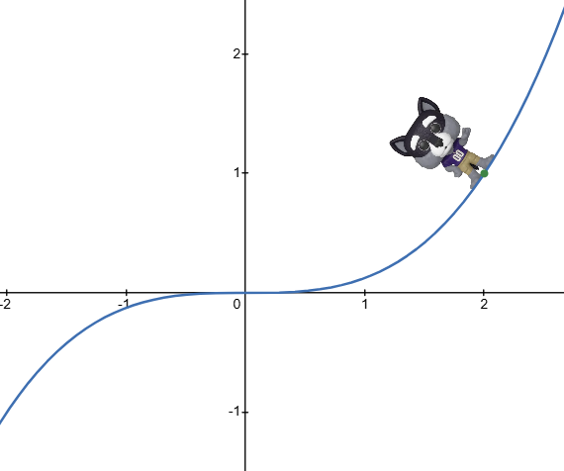
14.5 The Chain Rule
Recall: The Chain Rule from Calculus 1
$$\frac{dy}{dt}=\frac{dy}{dx} \frac{dx}{dt}$$
Example:
Find $\frac{dy}{dt}$ in two ways.
$$y={\frac{1}{8}x}^{3}, x=t^{2}-2$$
(a) Substitute first.

(b) Use the chain rule.

https://www.desmos.com/calculator/omcdt4vltj

Case 1: Two inputs depending on time
Given $z=f\left(x,y\right),x=x\left(t\right),y=y\left(t\right)$
$\frac{dz}{dt}=f_{x}\frac{dx}{dt}+f_{y}\frac{dy}{dt}$
Example:
$$z=xy^{2}-x^{3}y, x=t^{2}, y=t^{3}$$
Find $\frac{dz}{dt}$ when t = 1 in two ways
(a) Substitute first.

(b) Use the chain rule

Note 1: Connects to linear approximation
$$Δz≈f_{x} Δx+f_{y} Δy$$
$$\frac{dz}{dt}=f_{x}\frac{dx}{dt}+f_{y}\frac{dy}{dt}$$

Note 2: Chain Rule Tree Diagram
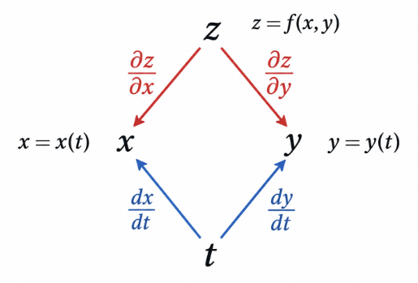
multiply along branches and add results.
Case 2: Two independent variables HW Q2 $z=f\left(x,y\right), x=x\left(s,t\right), y=y\left(s,t\right)$
$$\frac{∂z}{∂s}=f_{x}x_{s}+f_{y}y_{s}$$
$$\frac{∂z}{∂t}=f_{x}x_{t}+f_{y}y_{t}$$

Example:
$$z={2x}^{2}-{2y}^{2}, x=s^{2}-t, y=s-t^{3}$$
Find $\frac{dz}{ds}$ and $\frac{dz}{dt}$ when t = 1 and s = 1

Note: Chain Rule Tree Diagram
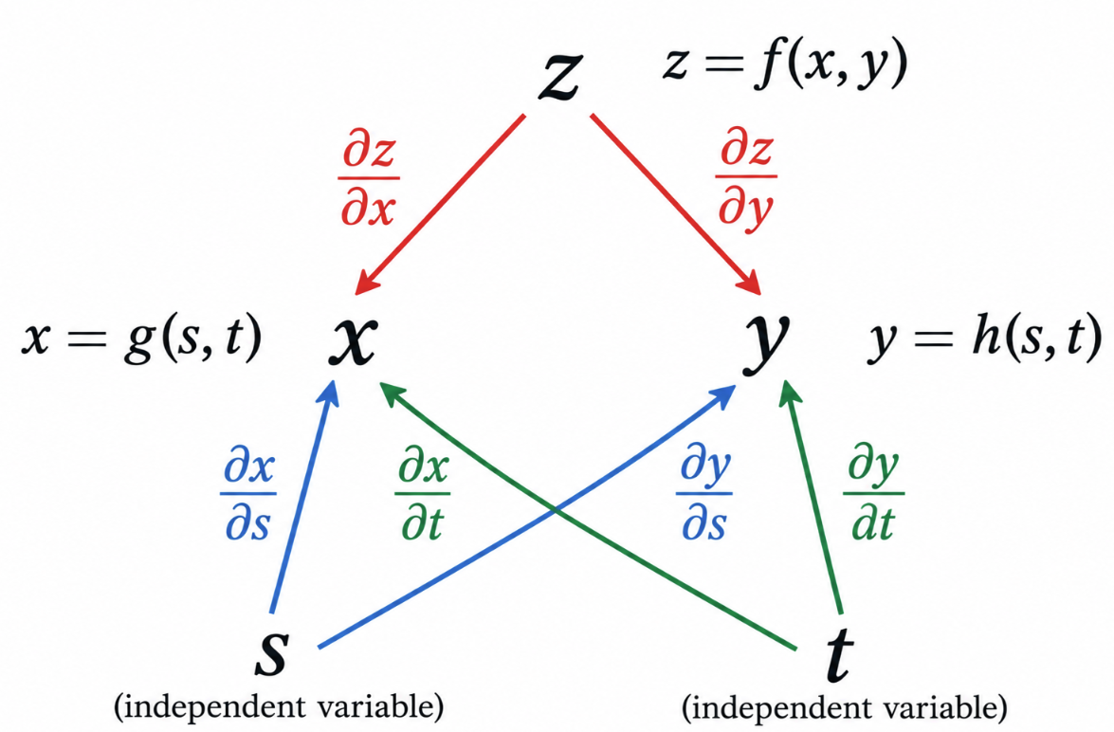
multiply along branches and add results.

Chain Rule with Given Rates HW Q3–4
$$p\left(t\right)=f\left(g\left(t\right),h\left(t\right)\right)$$
Sometimes we know the derivatives of f at a point, but not a formula for f.
$$g\left(5\right)=8, h\left(5\right)=3,$$
$$g'\left(5\right)=-5, h'\left(5\right)=4$$
$$f_{x}\left(8,3\right)=5, f_{y}\left(8,3\right)=3$$
Find $p'(5)$.

Implicit Differentiation Revisited
Consider the surface
$$x^{2}+2y^{2}+9z^{2}=1$$

- Find $\frac{∂z}{∂x}$ using implicit differentiation.

(b) Now consider
$$w=x^{2}+2y^{2}+9z^{2}-1$$
Find $\frac{∂w}{∂x}$ and $\frac{∂w}{∂z}$.

Note: Implicit Shortcut - Given an implicit equation, get everything to one side and differentiate with respect to each variable separately and use…
$$F\left(x,y,z\right)=0⇒z_{x}=-\frac{F_{x}}{F_{z}}, z_{y}=-\frac{F_{y}}{F_{z}}$$
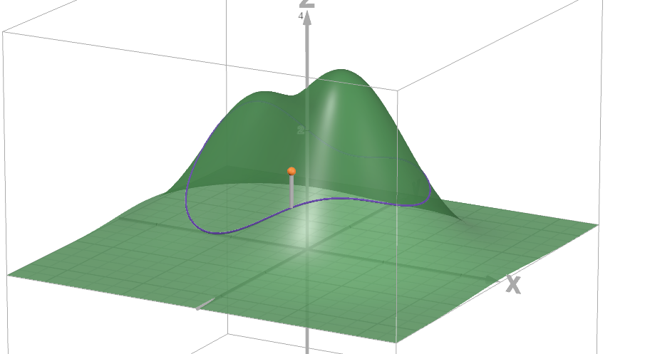
Optional: Walking Across a Landscape
A walker follows a path across the surface
$$z=f(x,y).$$
$$r\left(t\right)=⟨x\left(t\right),y\left(t\right),f\left(x\left(t\right),y\left(t\right)\right)⟩$$
How quickly is the walker gaining or losing elevation?

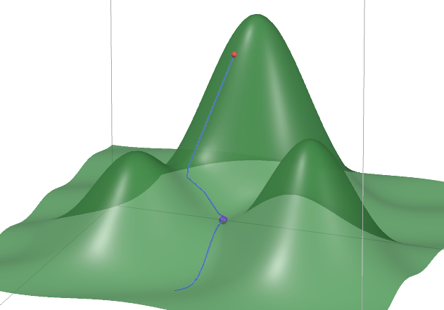
Optional: A River Thru a Mountain
A river is traveling down a mountain range defined by $z = f(x,y)$.
No matter how it meanders down, what must be true about the change in height with respect to the river’s length?
Meaning what can you say about
$$\frac{dz}{ds}$$

